Right to Receive a Complete

Explanation of IDEA’s
Procedural Safeguards
A handout in CPIR’s module Right to Receive Notice
and to Participate in Meetings
August 2021 | Additional eLearning Hub Resource
from the Center for Parent Information and Resources
https://www.parentcenterhub.org/notice-safeguards/

At least one time a year…
…the parents of a child with a disability must receive from the school system a complete explanation of all the procedural safeguards available to them, as parents, under IDEA. This explanation is called the “Procedural Safeguards Notice.” Let us examine the purpose and contents of this notice, the times that parents will receive it, and other aspects of this important safeguard.

What is the purpose of the procedural safeguards notice?
The purpose of the procedural safeguards notice is simple: to inform parents completely about the procedural safeguards available under IDEA. These represent their rights as parents and the protections they have—and their child as well—under the law and its implementing regulations.

When can you expect to receive the procedural safeguards notice?
IDEA states that schools must send the procedural safeguards notice to the parents only one time a school year, except that schools must also give a copy to parents:
- in their child’s initial referral for evaluation under IDEA, or when the parents ask for such an evaluation of their child;
- the first time in the school year that a State complaint is filed and when the first due process complaint is received in a school year;
- in accordance with the discipline procedures en §300.530(h); and
- when a parent requests a copy of the procedural safeguards notice.
Your local school district may also post a current copy of the procedural safeguards notice on its website, if it has a website.

What does the procedural safeguards notice contain?
The procedural safeguards notice must include a complete explanation of all the safeguards available under IDEA related to:
- Independent educational evaluations
- Prior written notice
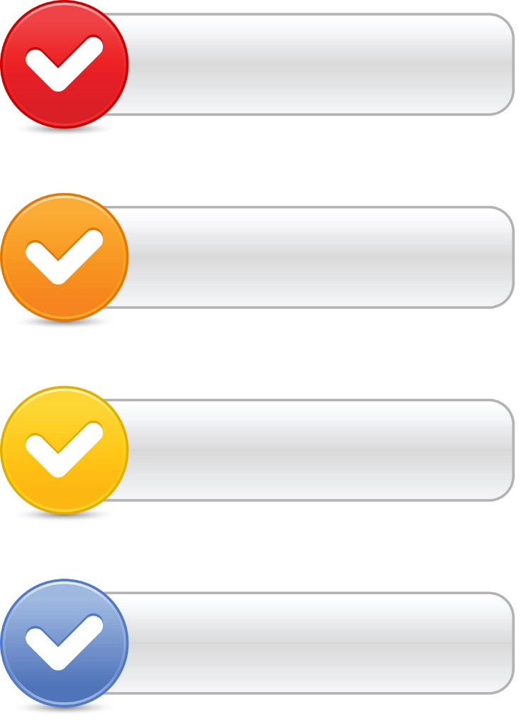
- Parental consent
- Access to student education records
- The opportunity to present and resolve complaints through procedures for due process complaint and for State complaints, including–
–the timeline for filing a complaint;
–the opportunity for the school system to resolve the complaint; and
–the differences between the scope of the two procedures such as their jurisdiction or authority, issues covered, filing and decisional timelines, and relevant procedures;
- The availability of mediation;
- The child’s placement during the pendency of any due process complaint;
- Procedures for students who are subject to placement in an interim alternative educational setting;
- Requirements for unilateral placement by parents of children in private schools at public expense;
- Due process hearings, including requirements for disclosure of evaluation results and recommendations;
- Appeals at the State level (if applicable in the State);
- Civil actions, including the period of time in which to file such actions; and
- Attorneys’ fees. [§300.504]
In addition to providing this explicit information, the procedural safeguards notice must be written in understandable language.

What qualifies as “understandable language”?
Under IDEA, the procedural safeguards notice (and, for that matter, the prior written notice) must be:
- written in a language understandable to the general public; and
- provided in the native language of the parent or in another mode of communication that’s used by the parent, unless it is clearly not feasible to do so. [§300.503(c)]
If the native language or other mode of communication used by the parent is not a written language, then the school must take steps to ensure:
- that the notice is translated orally or by other means to the parent in his or her native language or other mode of communication;
- that the parent understands the content of the notice; and
- that there is written evidence that these requirements have been met. [§300.503(c)]
Is there an example of a procedural safeguards notice?
Yes. The U.S. Department of Education makes a Model Form available online: https://sites.ed.gov/idea/files/modelform_Procedural_Safeguards_June_2009.pdf
May the school send the procedural safeguards notice via email?
Yes, at the discretion of the parents. IDEA says that the parent of a child with a disability may elect to receive the notice by email, if the school makes that option available.

What should a parent do, if he or she doesn’t understand the notice from the school?
Parents can get in touch with the Parent Center for their state. Parent Centers typically can provide parents with explanations of key IDEA-related rights and responsibilities, as well as informative materials and training. Each state has at least one Parent Center.

To identify the one serving your area, visit our Find Your Parent Center page, at:
https://www.parentcenterhub.org/find-your-center

________________________________________________________
Highly Rated Resource! This resource was reviewed by 3-member panels of Parent Center staff working independently from one another to rate the quality, relevance, and usefulness of CPIR resources. This resource was found to be of “High Quality, High Relevance, High Usefulness” to Parent Centers.
________________________________________________________

The CPIR is made possible through Cooperative Agreement Number H328R180005 between OSEP and the Statewide Parent Advocacy Network (SPAN). The contents of this document do not necessarily reflect the views or policies of the Department of Education, nor does mention of trade names, commercial products, or organizations imply endorsement by the U.S. Government.

